**Ideation Phase**

**Define the Problem Statements**

| Date | 19 September 2022 |
| --- | --- |
| Team ID | PNT2022TMID02117 |
| Project Name | Project - Data Analytics for DHL |
| Maximum Marks | 2 Marks |

**Customer Problem Statement Template:**

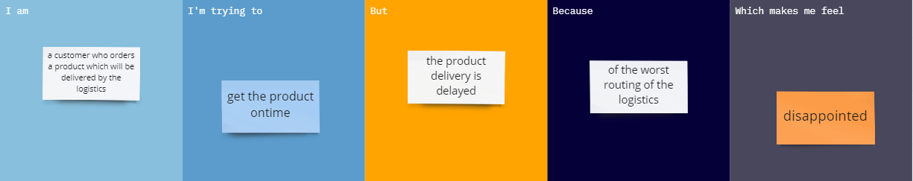

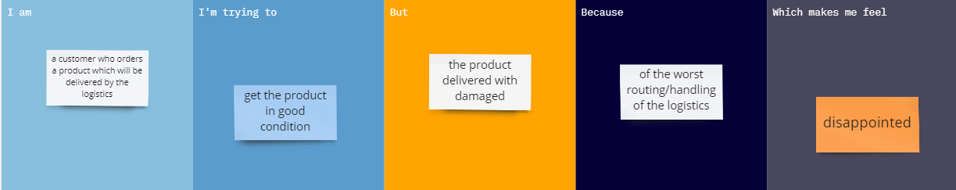

| **Problem Statement (PS)** | **I am (Customer)** | **I’m trying to** | **But** | **Because** | **Which makes me feel** |
| --- | --- | --- | --- | --- | --- |
| PS-1 | a customer who orders a product which will be delivered by the logistics | get the product in good condition | the product delivered with damaged | of the worst routing/handling of the logistics | disappointed |
| PS-2 | a customer who orders a product which will be delivered by the logistics | get the product on-time | the product delivery is delayed | of the wrong/worst routing of the product | disappointed |